Lloyds of London

Lloyds is a gathering place in London, England for insurance Underwriters. Lloyd's is not an insurance company. It is an insurance market of members. As the oldest continuously active insurance marketplace in the world, Lloyd's has retained some unusual structures and practices that differ from all other insurance providers today.
Lloyd's itself does not underwrite insurance business, leaving that to its members (see below). Instead the Society operates effectively as a market regulator, setting rules under which members operate and offering centralized administrative services to those members.
Lloyd's is a marketplace made up of hundreds of underwriting syndicates, each of them in effect a mini-insurer. Lloyd's sets standards for its members, but does not issue policies itself. Each syndicate is managed by an underwriter who decides which risks to accept. Typically, a risk underwritten at Lloyd's will be shared by many syndicates. The number of individual investors, known as "names," in a particular syndicate may vary from a few to hundreds. The Lloyd's market is also a major international reinsurer, allowing other insurance companies to limit their risks.
This diagram is a basic representation of the structure of the market and its participants. A detailed description of the participants can be found below.
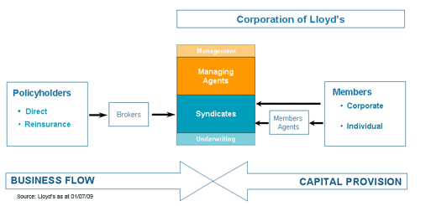
Placing risk at Lloyd’s
The following is a brief synopsis of how risk is placed at Lloyd's.
•A customer approaches a Lloyd's broker (either directly or via an intermediary) with the details of a risk to be insured.
•The Lloyd's broker approaches an underwriter to discuss premium, terms and conditions. If both parties remain interested, a proposal will be made to accept a percentage of the total risk. A number of underwriters may accept portions of one risk (either within Lloyd’s or outside).
•The Lloyd's broker feeds back the proposal to the customer.
•If the customer wants to proceed, the Lloyd's broker prepares a 'slip' with the details of the insurance, which is signed by each of the underwriters that have agreed to accept part of the risk (“subscription”).
•The Lloyd's broker deducts its fee from the premium paid by the customer and pays the net amount to Lloyd's which then allocates it to the syndicates.

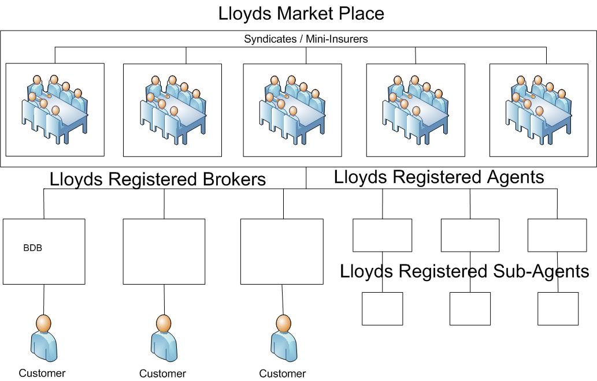
Members of Lloyd's
Members of Lloyd's, or 'capital providers' as they are often known, accept insurance business through syndicates on a separate basis for their own profit and loss (in other words, members of Lloyd's are not jointly responsible for each other's losses). The membership of Lloyd's comprises a mix of corporate (limited liability) members and individuals. Private members tend to support a number of syndicates, whereas some corporate members only underwrite through a single syndicate.
Syndicates
Lloyd's members conduct their insurance business in syndicates, each of which is run by a managing agent. The syndicates operating within the market cover many speciality areas including:
- Marine
- Aviation
- Catastrophe
- Professional indemnity
- Motor
Syndicates tailor solutions to respond to the specific risks of the client base.
Syndicates compete for business, thus offering choice, flexibility and continuing innovation. Syndicates cover either all or a portion of the risk and are staffed by underwriters, the insurance professionals on whose expertise and judgement the market depends.

Lloyd's brokers
Accredited Lloyd's brokers place risks in the Lloyd's market on behalf of clients. These brokers use their specialist knowledge to negotiate competitive terms and conditions for clients.
Currently there are over 180** firms of brokers working at Lloyd's, many of whom specialise in particular risk categories. Each Lloyd's broker is required to demonstrate an understanding of the Lloyd's market, as part of Lloyd's assessment of its suitability to be accredited as a Lloyd's Broker.
Lloyd's operates an accreditation process for brokers seeking access to the Lloyd's Market. All brokers must satisfy all relevant regulatory requirements. Lloyd's performs a careful assessment of all applicant brokers, affirming their reputation and financial standing and investigating the character and suitability of officers and employees before making the decision to accredit.

Local brokers
Any insurance broker can access the expertise and resources of Lloyd's by making contact with an accredited Lloyd's broker.

Lloyd's Agents
Agent’s main role today is one of conducting or arranging surveys on ships and cargoes for insurers and commercial interests throughout the world. Almost 200 Agents have also been granted authority to adjust and settle claims arising under Lloyd's certificates of insurance.

Primary role of the Agent
The primary role of the Lloyd's Agency Network is to provide a high quality survey and adjusting service for the Lloyd's marine insurance market. Today many underwriters and their assureds throughout the world utilise the services of Lloyd's Agents and evidence of this is usually reflected in the wording of cargo insurance certificates which often incorporate the clause: 'In the event of loss or damage which may result in a claim under this insurance, immediate notice should be given to the Lloyd's Agent at the port or place where the loss or damage is discovered, in order that he may examine the goods and issue a survey report'.
It should be noted that in carrying out surveys or other tasks, whether for insurers or other principals, the Agent is being employed directly by these parties and is not acting as an Agent of Lloyd's underwriters unless specifically instructed by them.
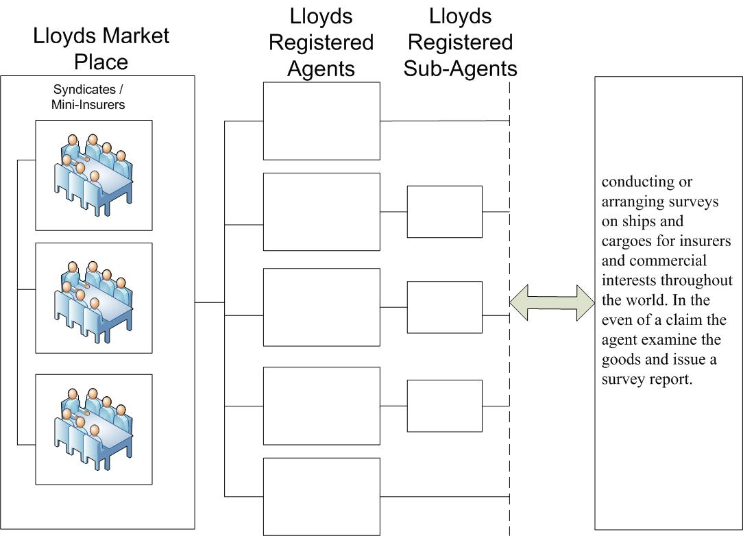

A client approaches a broker about insurance cover. The broker examines the risks, decides what type of insurance cover is required and then, using their knowledge of the market, identifies the most suitable insurer(s) and arranges a bespoke package of insurance cover on behalf of the insured. The broker may be entitled to commission from the insurer(s), which would form part of the premium. The insurer must include the commission paid to the broker when accounting for IPT. However, the broker may waive part or all of the commission due to them from the insurer in favour of charging a separate fee, under a separate contract, to reflect the work that they have undertaken on behalf of their client. This is purely a commercial decision and arrangement between the broker and their client. In these circumstances the separate fee would not form part of the premium for IPT purposes (unless it is charged in relation to a contract subject to the higher rate).

Lloyds Reinsurance
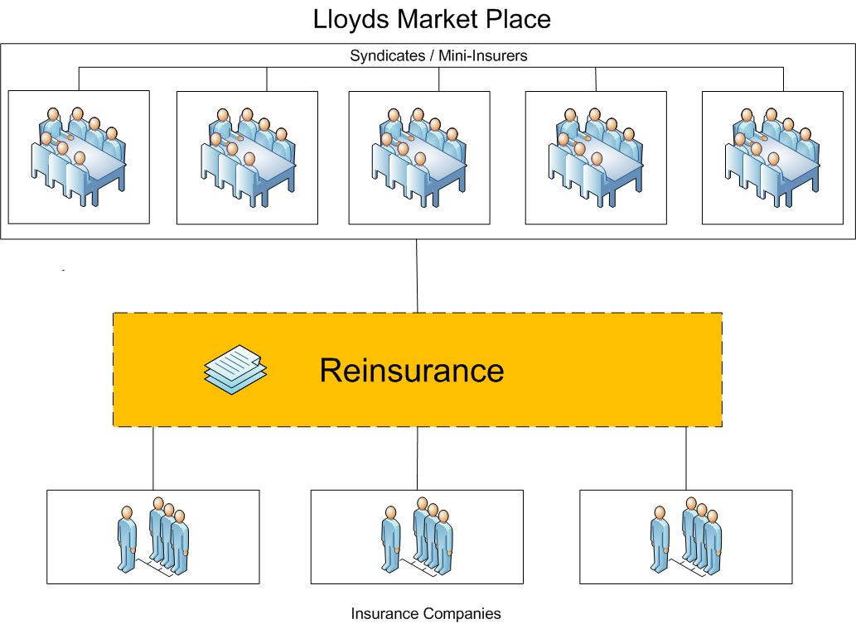

Flow of Insurance Premium



